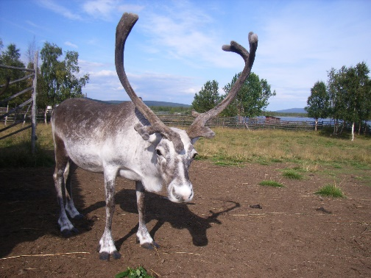
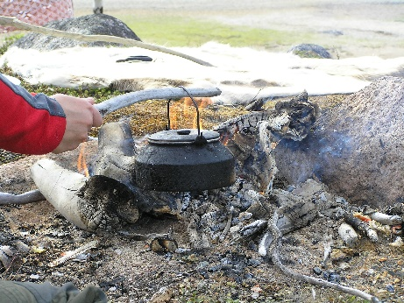
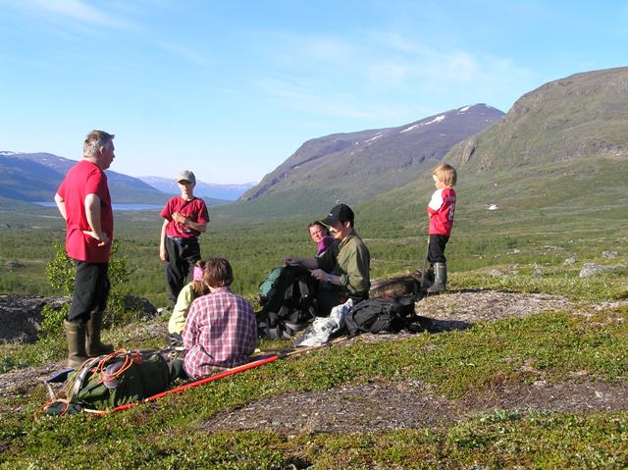
Package tour 4 days: Luondu summer - nature in Sápmi
We welcome you to Reindeer Lodge for four incomparable days, days filled with adventure and new experiences. Try both hiking in the mountains and go fishing. You live in our newly built goahti tents, a more comfortable version of cabins where we have combined the best of glamping and the Sámi nomadic lifestyle.
Day 1 – Arrival
You check in at a goahti and get both time to familiarize yourself with the area and your tent.
Day 2 – Gáisi – Mountain hike in Sápmi 09.30 – 17.00
This is a perfect day trip for those interested in fresh mountain air and nature which is home to the Sámi people and reindeer, a cultural landscape that also is affected by railway and other activities. The guide will pick you up by minibus at Reindeer Lodge and take you up to the mountains, all in less than an hour's drive. We park the bus at Torneträsk station, check our equipment and start our hike with a light incline through low mountain birch forest and up above the tree line. The bare mountain area welcomes us with stunning and expansive views, snow-capped mountain peaks and lush valleys. Wildlife is rich and if we are lucky, we can observe migrating reindeer and lemmings. Our guide’s trained eyes make it more likely that we do not miss anything along the way, and there is time to stop and enjoy, at a murmuring mountain creek for example. The water is clean and crystal clear and tasting a cup of water from the brook is both refreshing and thirst-quenching. The hike is approximately 5 to 8 kilometres where the final view from mountain Nagirvárri is worth the effort. We make a stop at a suitable spot for our lunch break. Food is part of the experience, and we prepare it from ingredients from nature’s pantry in Sápmi. While the coffee is brewing, our guide talks more about nature, wildlife and reindeer husbandry that is conducted in this territory and shares exciting experiences hir has had. When we come down from the mountain again, we head back to the lodge.
Day 3 – Oaggut – Set out and fish 10.00 – 17.00
Fishing, together with trapping and hunting, is the oldest livelihood in Sámi society. For some Sámi people, fishing has been the main source of income and for many reindeer herders it was lifesaving during years with bad reindeer pasture. There is even an old Sámi expression that says, “one does not dare to trust the forest, but the lake does not perish a man”. Therefore, we invite for a wonderful fishing adventure at national rivers or lakes nearby, fishing for among others, artic char, trout, whitefish, grayling and pike. A perfect day trip for those interested in easy-accessible fishing and the beautiful nature. The guide picks you up by minibus at Reindeer Lodge and takes you to the waters we prefer and where the fish are usually plentiful. We start fishing immediately when we arrive, so we do not miss a minute. When the coffee craving kicks in, we make a small fire. Your guide will happily tell you more about Sámi culture and its connection to fish and waters. The lunch, of course, consists of fish, hopefully self-caught but guaranteed local. If you prefer to fish with your own equipment, you are welcome to do so. We always work with fishing in an ethical and sustainable way, regardless of whether you choose to pick up the fish for lunch or to release the catch. We inform you about regulations that pertain the day and to the area of water when we go fishing with you.
Day 4 – Departure
After breakfast, it's time to pack, say goodbye and travel on.
PRICE: SEK5985/adult. The prices are for 2 people/cottage/Child 2-13 years SEK2995.
SEK8970 singleroomstay
PERIOD: 5 June – 15 September
START: Check-in from 15.00 day 1.
END: Check-out no later than 11.00 a.m. Day 4.
ACCOMMODATION/FACILITIES: 3 nights in private goahti at Reindeer Lodge included. Reindeer Lodge includes three private goahti in Sámi design. Each goahti is like a large room of 20 m² which is equipped with a double bed, wood-burning stove, eco-toilet.
Access to shared service building for self-catering with fully equipped kitchen, stove and seating, barbecue area, as well as separate shower and WC:in shared facilities.
ACTIVITIES: 1x Gáisi - Mountain hike in Sápmi and Oaggut - Set out and fish included.
MEALS: Breakfast (07.30 - 10.00) days 2, 3 and 4 is included. Lunch on day 2 and 3 is included.
Food allergies/intolerances are stated when booking.
EQUIPMENT: Bed linen, bath towel, wood for the stove included.
EXCLUDED: Travel insurance, international and domestic transport.
TERMS: Guests participate in our activities at their own risk and have an obligation to follow the guide's assigned safety instructions. All tours are adapted to prevailing weather conditions.
ADDRESS: Lodge: Paksuniemivägen 188, SE - 981 91 Jukkasjärvi.
SUPPLEMENT Optional: Dinner experience árrangaddis day 1, 2 or 3: SEK880 /adult.
GOOD TO KNOW: If you do not book a transfer, a car is recommended to get here, for the sake of mobility and flexibility. The bus connection with line 501 is limited and there is no stop near the lodge; Paksuniemivägen is without a footpath. The nearest grocery store, café and restaurant is 3 km away in Jukkasjärvi. The Reindeer Lodge facility is only partially staffed.
The guests are responsible for the communal facilities being kept clean during the stay and left in good condition upon check-out. In insufficient cabin cleaning, there will be extra cleaning fee of SEK 1,000/cabin. The cleaning and instructions are available on site. Reindeer Lodge is a non-smoking establishment.
QUALITY: Sápmi Experience and Sustainable Arctic Destination certified

