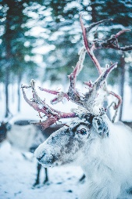
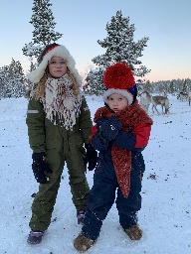
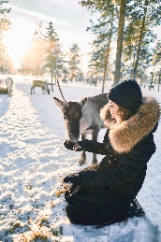
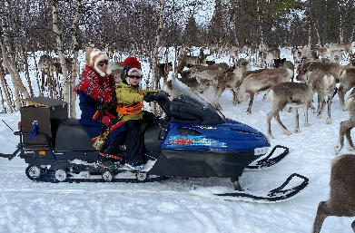
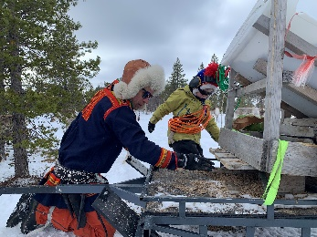
Ruovttus - Homestay with Simon Issát
Simon Issát Marainen invites you home for a unique opportunity to get close to the Sámi lifestyle, simply by living it! Get to experience life as a reindeer herder while you live in a cottage on Simon Issát's yard, help him with the reindeer and listen to his stories. The days are filled with both reindeer herder chores and free time to explore the local area yourself. So come and visit the Márainen family in Nedre Soppero where you can enjoy the barren winter landscape and the warm hospitality in an unforgettable, personal experience.
Being a reindeer herder is more than a job, it's a lifestyle. Everything is affected by the reindeer and no two days are the same, therefore this trip is more than just a holiday. The Márainen family invites you home to the small village of Nedre Soppero, with about 30 residents and next to the Lainio River, to give you a unique insight into their everyday lives. On the yard, three generations live together, and you get to stay in a cozy cottage right next door. During your stay you will meet Simon Issát's children, partner, parents and of course the most important helper of reindeer husbandry: the herding dogs. The everyday language is Sámi and it is spoken consistently, so when you go home again you will hopefully have learned a few words!
While you live here, you are included in all everyday chores. You can follow Simon Issát out to the forest where the reindeer graze surrounded by frost-covered spruces and piles of snow. There you can try hand-feeding the reindeer calves, go old-fashioned skiing and make coffee over an open fire. In addition to the arranged activities, there is plenty of time for your company to socialize and have valuable time together.
The whole family are creative souls, and this is to be seen everywhere. Simon Issát's parents are craftsmen and in their workshop you can see everything from world-class silversmithing to unique antler handicraft. Simon Issát is also a reputable artist and one of Sápmi's big names when it comes to both traditional and innovative yoik. As the icing on the cake on this unforgettable trip, he promises you an intimate concert one of the evenings.
Thanks to the small group, a maximum of 3 adults or 2 children and 2 adults, you get the chance to make the trip your own. In addition, the tour can only be booked for closed parties, so you get the experience for yourself. The days are affected by season, weather and wind so no one knows exactly how the stay will be shaped.

PRICE: SEK 16,500, price includes 2 people.
Extra adult supplement: SEK 8,250. Children price (3-12 years): 4125 SEK
GROUP SIZE: No more than three adults are allowed per cabin, and we recommend no more than two adults and
two children. This is due to limited space and beds.
PERIOD: 9 Jan - 16 April 2023. Package 3 days, 2 nights
TOUR START: Monday everything. Friday 10:00 at pick-up in Kiruna, 10:30 at pick-up in Jukkasjärvi.
FINAL: Wednesday alt. Sunday 17.00 in Kiruna, 16:30 Jukkasjärvi
* TRIP AND RETURN TRANSFER BY MINIBUS / PASSENGER CAR from Kiruna to Nedre Soppero. Driving time approx. 1.5 hours / single way
ACCOMMODATION: Nedre Soppero, A small town with approx. 30 permanent residents in the northeastern part of
Kiruna municipality. Own comfortable cottage with open floor plan, electricity, wood stove, toilet
and shower, small kitchen. 1 double bed, 1 sofa bed. Cottage size about 20 square. Bed linen,
towels and cleaning areincluded
FOOD: Breakfast lunch dinner. Coffee, tea and meal drinks. Alcoholic beverages are not included in the
price. Beer / Win is available to buy extra for food.
EQUIPMENT: Winter clothes Thermo overalls, Boots, Hat, Gloves included in the package. Wooden skis/poles
included.
LANGUAGE: Sami, Swedish, Norwegian and English.
TERMS: Guests participate in our activities at their own risk and have an obligation to follow the guide's
designated safety instructions. The tour is adapted to prevailing weather conditions. Even if the
chance of seeing the northern lights is high, it can not be guaranteed because it is a natural
phenomenon.
QUALITY: Sápmi Experience and Sustainable Arctic Destination certified

