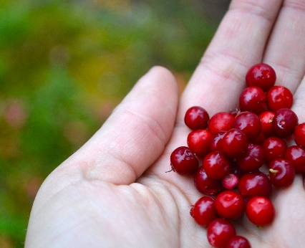
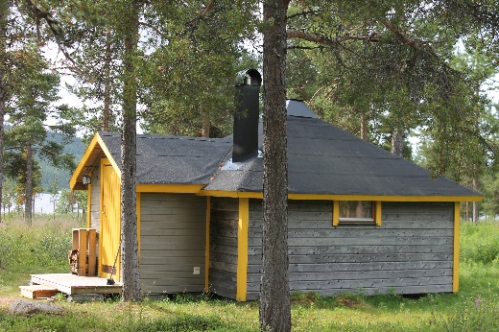
Reindeer Lodge
Stay amidst nature and with a Sámi touch outside Jukkasjärvi village. Choose between a cosy forest cabin (stohpu) and a comfortable Sámi tent (goahti), or why not traditional tent (lavvú)? Nestled in the woods and on the banks of river Torne, this small-scale and snug accommodation facility with plenty of space offers an ideal base for your Swedish Lapland getaway.
During the period from late April to late autumn, we have no reindeer grazing at the lodge, but instead a free ticket to the Márkanbáiki Museum is included, where you can meet and feed some reindeer during summer and autumn.
Stohpu – Forest cabin
Make a cosy cabin a resting place during your holidays. Our five wooden cabins in Sámi design are inspired by the reindeer herder cabins that used within reindeer husbandry. Each cabin is like a large room of 20 m² which is equipped with a double bed (1.60 x 2.00 m), wood-burning stove, electrical heaters, refrigerator, chairs and a table. Four out of five cabins are also furnished with a sofa bed (1.60 x 1.80 m) that can accommodate another adult or two children. The cabin is decorated with elements and designs from nature and the Sámi culture and a great accommodation in the woods.
WC, single-sex shower and changing rooms, breakfast room/guest kitchen are in separate common facilities located a few meters from the cabins. There is access to common barbecue area too.
Breakfast is served in the morning for a good start to the day.

Goahti – Modern Sámi tent
Move into a comfortable Sámi tent for a couple of days with adventurous touch to get a sense of reindeer herding lifestyle, albeit in a slightly arranged and pleasant way. Here we combine the best of glamping and the nomadic Sámi lifestyle in our three goahti tents. Each goahti is a tent room of 20 m² which is characterised by its conical shape that is created by the circular floor area and the one-meter-high insulated outer walls which are topped with long wooden poles that form the roof’s framework. A high-quality tent canvas that withstands wind, rain and snow encases the roof’s framework and thus creates a real close-to-nature experience.
The goahti tent is also raised a bit above the ground and has insulated wooden floor. It is furnished with a double bed (1.40 m x 2.00 m), wood-burning stove, modern oil stove, chairs and a table. A combustion toilet is built into the goahti tent for comfort reasons. The interior of the goahti tent features Sámi design and natural materials. Candle lights enhance the lovely cosiness in this special type of lodging even more.
WC, single-sex shower and changing rooms, breakfast room/guest kitchen are in separate common facilities located a few meters from the tents. There is access to common barbecue area too.
Breakfast is served in the morning for a good start to the day.

Lávvu – Traditional Sámi tent
Go back to the roots and stay a night in a lávvu, a traditional Sámi tent used by the nomadic mountain reindeer herding Sámi people year around during the past, and still in use by some the during bare ground season! The lávvu is a portable conical tent dwelling with the ground floor covered with birch branches and big reindeer hides stretched across. Long wooden poles meeting at the top make up the tent’s framework that is wrapped with durable canvas. In the middle of the lávvu there is a wood-burning stove as heat source and for coziness. You sleep on a mattress made of soft reindeer skins, curled up in a warm thermal sleeping bag.

See & do
Make the most out of your stay by exploring the surroundings during a forest walk, by swimming in the nearby creek or berry picking. Gather around the common barbecue site to eat your own cooked meal and to engage in conversations with other guests in an unbent atmosphere or visit our Café Sapmi for lovely dinner. In the summer it is bright day and night and in autumn when the nights get darker there is a chance to see the northern lights.
In Jukkasjärvi village you can visit the church, Icehotel 365 and the open-air museum Márkanbáiki. Do not miss dropping by Café Sápmi if you want to taste smoked reindeer meat and have a good coffee.
During spring, summer and autumn there are no reindeer residing at Reindeer Lodge due to natural reasons, but you are welcome to see some of them at Márkanbáiki (from 6 June) – Reindeer Lodge guests have free museum admission during non-winter season. We also provide different bookable activities, read more about that on our website.
Reindeer Lodge is perfect for travellers by car who look for an accommodation off-the-beaten track, still easily accessible; situated only 15 km from Kiruna Airport and 20 km from central Kiruna. We offer scheduled check-in/out transfer with minibus against supplement.
PRICE STOHPU – SEK 1490 for 2 per cabin/night.
FOREST CABIN: Max 3 adults/cabin with sofa bed.
SEK 1490 for 1 person per single cabin/night.
Note: the sofa bed (1.60 x 1.80 m) fits one adult or two children (3-12 years).

PRICE GOAHTI – SEK 1990 for 2 per goahti-tent/night.
Modern Sámi tent: SEK 1990 for 1 person per single goahti tent/night.

PRICE LÁVVU – SEK 1990 for 2 adults per lávvu tent/night.
TRAD. Sámi tent: Max 2 adults/lávvu tent, no children.
SEK 1990 for 1 person per single lávvu tent/night.

PERIOD: 17 April - 13 November 2023.

INCLUDED: Breakfast 08.00 - 10.00, bed linen and towels. Access to separate shared facilities comprising WC, single-sex shower and changing rooms, breakfast room/guest kitchen and barbecue site. Free parking.

SELF-CHECK-IN: From 15.00. CHECK-OUT: 11.00 at the latest.

ADDRESS: Paksuniemivägen 188, SE-981 91 Jukkasjärvi.

SUPPLEMENTS: Transfer with minibus (SEK 300 per person/route; to be pre-booked; limited no of seats):
Check-in transfer: 15.00 from Tourist Center to Reindeer Lodge.
Check-in transfer: 16.00 from Márkanbáiki Museum to Reindeer Lodge.
Check-out transfer: 11.00 from Reindeer Lodge to Márkanbáiki Museum/Icehotel/Kiruna Airport/ Tourist Center/Kiruna train station.
Departure cleaning fee SEK 500/cabin and goahti tent.

GOOD TO KNOW: A car is recommended for getting here, for mobility and flexibility reasons. Local bus no 501 has a limited time schedule and there is no bus stop close to the lodge. Bus 501’s bus stop “Jukkasjärvi Kyrkan” (church) outside Márkanbáiki Museum works also as a pick-up spot for our 16.00 check-in transfer (against pre-booking only).
Lodging is without lunch and dinner; dinner is served daily at Café Sapmi in the village,
free transfer will be provided.
The Reindeer Lodge facility is partly staffed only.
Lodging is not adapted for toddlers.
Cabin and tent to be left cleaned by tenant on departure day, alt departure cleaning can be pre-booked for SEK500/cabin and goahti tent.
Tenant is responsible to keep the communal facilities tidy during the stay and to return them
in good condition upon departure. Cleaning kit and instruction on site. If cabin is left insufficiently cleaned, an additional cleaning surcharge of SEK 1000/cabin and goahti tent, resp, will be imposed on tenant. Reindeer Lodge is a non-smoking facility. In the event of violation of the smoking ban the facility has the right to charge the customer demolition costs.

QUALITY: Nature’s Best Sweden, Sápmi Experience and Sustainable Arctic Destination certified.

